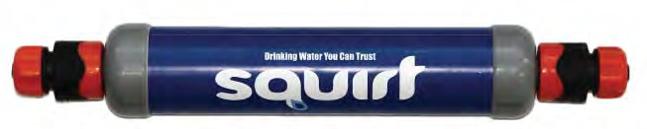
SAFEWATER FILTER
with PATENTED SHAKE & FLUSH CLEANING PROCESS

The perfect MSG solution for making drinking water safe!

Simply connect the SQUIRT to an overhead bucket for an endless supply of safe clean water
The SQUIRT-25 uses proven world class “passive” ultrafiltration that eliminates contaminants (pathogens, turbidity & bacteria) delivering safe, clean drinking water anywhere

500+
EASY CLEAN
L/day
SM&ALL LIGHT

SQUIRT SAFEWATER FILTER
Meets WHO Key Drinking Water Indicators

Removes up to
99.9999%

of all contaminants

Features
Small, lightweight & portable

Easy to use - does not require technical skills Requires NO power - uses gravity flow system Removes dirt, turbidity, pathogens, bacteria (key WHO Indicators) 0.04 Um poresize
Quick to clean “SHAKE & FLUSH PROCESS” for ongoing use - does not wear out
No chemicals added to drinking water Long life - can be stored until needed Designed for continuous use
Supplied by SkyJuice Foundation Inc.
www.skyjuice.org.au
Tel +61 438 880 621
info@skyjuice.org.au

SQUIRT is the perfect MSG water filtration solution or emergency & disaster solution. It is Ideal for instant drinking water from dams, creeks & rivers.

Community Use
The SQUIRT provides safe & hygienic drinking water for
remote communities, villages, schools and health clinics.

Portable Use
The SQUIRT is lightweight and portable. You can pack
it away, store and transport the SQUIRT for use at different locations. That means clean water for IDP sites, NGO requirements, hospitals, schools, staff camps, clustered rural communities anytime, anywhere.
NO POWER REQ’D
99%
.9999
REMOVAL
EASY TO USE

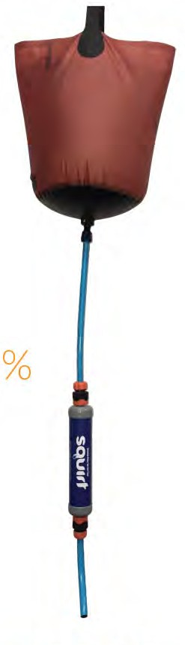

Setting up the Squirt -25
SMALL
LIGHT
&
EASY CLEAN
500+
L/day

Connecting the Squirt -25
Connect the SQUIRT to an overhead water supply such as a bucket or tank. The ideal water bucket head pressure (height above water collection bucket or tank) is about 1-1.5 metres (10to 15 kPa). Output quantity will vary depending on feedwater conditions.
The maximum water head pressure should not exceed
about 3m (30 kPa). If connecting to a tank, install a
valve to turn water flow off when cleaning the unit.

Activating the Squirt -25 (first time use only)
When using the SQUIRT for the first time flush at least 10 L of water through the SQUIRT to activate the filter fibres and remove surfactant salts. Only drink water after the first flush has been completed.

Cleaning the Squirt -25
To maintain a good flow of drinking water the SQUIRT needs regular cleaning to remove accumulated contaminants. Undertake cleaning daily or as often as needed to maintain water flow.

“SHAKE & FLUSH” Cleaning Process:
- Unclick the SQUIRT from hose.
- Turn the SQUIRT upside down & shake vigorously until water stops flushing. If SQUIRT is extra dirty refill with water and repeat shake and flush process. Make sure to dispose dirty water to a suitable drainage area.
- Reconnect SQUIRT to hoses and continue water filtration process.

It is recommended to undertake a monthly soak and sanitise. Use a small funnel to add a 0.2% chlorine solution to the SQUIRT-25 and allow it to soak for about 3 hours. Then undertake a “Shake & Flush” clean 3 times. This unique process removes accumulated organic and biofilm matter leading to improves flow & performance.

Storing the Squirt-25
When not using the SQUIRT or storing the unit for extended periods, please make sure to keep the internal filter fibres moist so they remain active. After use, drain the SQUIRT and place caps over each end to prevent evaporation before placing into safe storage at room temperature.
ULTRAFILTRATION REMOVAL CRITERIA
(to 0.04um nominal)
ULTRAFILTRATION ULTRAFILTRATION
WILL REMOVE: WILL NOT REMOVE:
PATHOGENS (disease causing CHEMICALS: including Arsenic, organisms) removed (to log reduction Cadmium, Chromium, Copper, Cyanide, value > 4) by ultrafiltration include: Fluoride, Lead, Mercury, Nickel, Nitrate,
Nitrite, Sulphate
Bacteria Total coliform TC
Protozoa Total coliform TC MINERALS (hardness)
Cysts Ecoli SALINITY AND SALTS
Helminths Virus TOTAL DISSOLVED SOLIDS (TDS) UNPLEASANT TASTES
TURBIDITY (DIRT)
TOTAL SUSPENDED SOLIDS (TSS) IRON & MANGANESE

The World Health Organisation (WHO) reports that ultrafiltration provides complete removal of bacteria and viruses (disease causing pathogens) as outlined in WHO document “GUIDELINES FOR DRINKING WATER QUALITY” under “Treatment Process” as referenced in the WHO website.
SAFEWATER FILTER
with PATENTED SHAKE & FLUSH CLEANING PROCESS

SQUIRT-25 Specifications
Dimensions 38.5cm x 6 cm dia.
Weight 350 grams
Capacity Nominal 15-25 litres/Hr
Includes: SQUIRT-25 WATER FILTER
+ plumbing attachment each end.
Note: Bucket & Hose supplied separately.
E
US

FOR Y

READ
-

TER FIL
TER A
W T

SQUIR

500+
L/day

Designed and manufactured in Australia
Supplied by SkyJuice Foundation Inc.
www.skyjuice.org.au
Tel +61 438 880 621
info@skyjuice.org.au

